Afghanistan Polio Communication Review Recommendations

Communication Strategies for Polio Eradication

Afghanistan polio communication review meeting
Kabul September 25-27, 2007

This report details recommendations presented at the conclusion of the Afghanistan Polio Communication Review meeting, held in Kabul in September 2007. These programme recommendations were generated by a panel of six national and international experts in the fields of epidemiology, behaviour change and health communication. The review panel undertook an assessment of the current polio eradication initiative (PEI) communication programme through a combination of a desk review of available data, a field visit to high risk and border areas in the provinces of Nangarhar and Laghman and provincial and national-level briefings. Specific recommendations are provided here in combination with an analysis of the perceived communication programme issues. They are presented with the goal of supporting and accelerating polio eradication efforts in Afghanistan, and form a resource to be used by Afghanistan’s polio communication teams in accordance with their own judgments and experience. The timelines for implementing these recommendations are by design very short and therefore build on existing capacity wherever possible.

Summary of findings
- Incredible strides have been made against great odds and it is critical to sustain the achievements of the programme as it moves towards eradicating polio.
- Communication has to play a central role in what comes next.
- The recommendations focus on quickly strengthening and expanding polio communication capacity through:
  - Reinforcing the current focus on high risk districts and locally tailored strategies.
  - Utilizing programme data to focus on, and refine, the highest impact activities.
  - Monitoring and follow-up for all SM/C activities.
  - And enhancing cooperation with Pakistan to ensure that the areas of circulation among the shared highly mobile border population are well-covered.

Background and Progress to 2007
Enormous gains have been made against very difficult and constantly evolving conditions since polio eradication activities began in Afghanistan in 1994. In 1999 there were 63 cases; this has been reduced to 10 cases (6 P3, 4 P1) as of September 2007. Circulation has been restricted since 2004 primarily to the South and East with only three sub-clusters (1 P3 and 2 P1). Good overall AFP surveillance has been established, though concerns remain regarding reporting within 7 days and ‘silent districts’. There is overall good coverage in accessible areas but gaps remain due to security and management problems. A national PEI system through which government works with donors and partners such as UNICEF, WHO, Rotary International and a range of NGO’s has delivered good results over the past decade. However, there is an urgent need to improve both operational and communication related SIA quality and to review communication strategies as Afghanistan moves towards the final phases of eradicating polio.

Communication and Social Mobilization Activities
Strong political commitment at the national level is an important and positive hallmark of Afghanistan’s polio programme. The Presidential Task Force, Polio Eradication National Steering Committee and Polio Action Group are testament to this commitment. The IEC department has been activated to support and guide polio eradication efforts in the country and there are regular SIA inauguration ceremonies at both the national and provincial levels. In July 2006 a strategy review designed to build consensus amongst all partners and with a particular focus on the south led to the implementation of a number of activities:
- The establishment of the Polio Communication Review (PCC) as a national level coordinating mechanism between all partners
- A strategic shift to social mobilization and greater emphasis in inter-personal communication (IPC) in high risk areas focusing on religious and community leaders, teachers and community health workers (CHWs).
- The development of a national branding and awareness campaign.
- An agreement to commission a behaviour change study.
- And the design and implementation of an IPC training module for vaccinators.
There has also been a stronger focus on cross-border immunization activities facilitated by national meetings between the Afghanistan and Pakistan governments as well as greater cooperation between border provinces.

Communication Challenges
However, there remain a number of significant challenges that need to be responded to urgently. The communication strategy at national and provincial levels has a number of gaps that need to be addressed very soon. There are insufficient human resources to implement polio Social Mobilization and Communication (SM/C) strategies at the national, provincial and district levels. Communication has only been weakly integrated into the overall PEI system at the national, provincial and district levels. There is limited programme data related to communication and lack of reliable communication baseline data. Additionally, the data that does exist is not utilized fully. The quality of monitoring and supervision is variable and quite poor in places especially high risk and inaccessible areas. There are gaps in inter-sectoral collaboration at sub-national level between line ministries and NGOs. Continued and increasing security issues in many areas are impeding access in the South and East. Cross border population movement both between Afghanistan’s provinces and between Afghanistan and Pakistan pose special challenges and while a number of initiatives have been started, more collaboration and joint planning will be required to ensure that coverage levels are maximized. Finally, many of the new high risk area initiatives continue to have difficulty accessing households and reaching child caregivers directly. Further work will need to be done to find ways to ensure that caregivers are more directly involved in the campaigns in relation to both building demand and improving caregiver capacity for decision making around children’s immunization.
Communication initiatives in Afghanistan will require better use of existing data and the development of indicators and data collection tools and processes to establish a communication programme in which measuring impact, reviewing strategies and refining approaches becomes integral at all levels. The last push towards eradication will require an intensification of the most effective SM/C activities and an evidence-based approach to communication (Figure 1) which should include the following major steps:
- Analyze existing sub-district data (surveillance, SIA, routine EPI, communication interventions) to show trends and assess impact or changes.
- Identify appropriate local-level communication activities (with appropriate monitoring and indicators in place) by either repeating, modifying or changing the previous SM/C activity.
- Implement the intervention, generate further data and analyse the impact of communication initiatives.
- Feed post campaign analysis back into the programme to inform the next round of activity.

Figure 1: Strategic Approach to Communication Activities
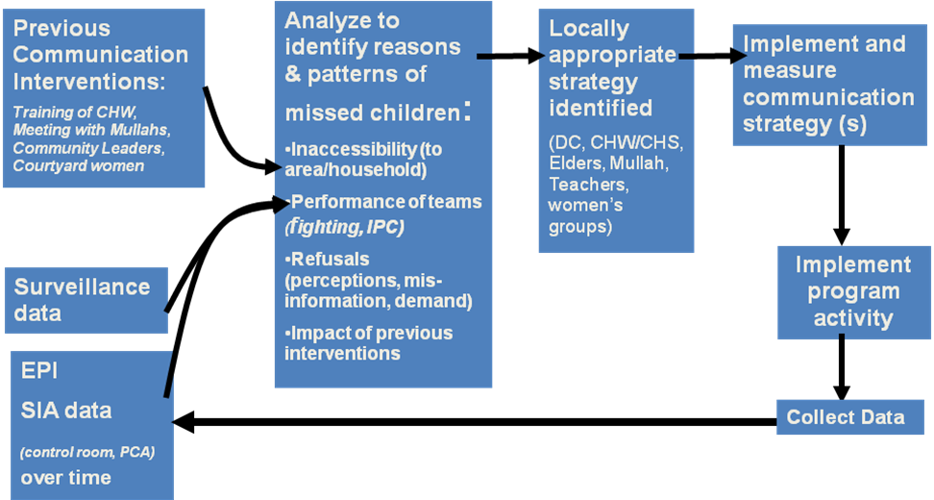

Recommendations

Communication planning and data
A comprehensive communication strategy needs to be developed urgently. It should utilize a data based approach to set overall direction and priorities to maintain gains in accessible areas, identify and support new and emerging approaches for high risk and inaccessible areas and be flexible enough to allow for adaptation to provincial, district and sub-district realities. The following time frame and priorities are recommended:
- By mid-November 2007: Develop a comprehensive communication strategy for national and provincial levels using data to identify high impact activities.
- By October 2007: Prepare and distribute an official MoPH directive calling for the integration of communication planning, implementation and monitoring into the PEI/EPI system at all levels.
- By November 2007: Ensure the development of indicators and updated social mobilization micro-plans at district and sub-district levels to address local challenges.
  - The focus should be on high risk districts: The Eastern and Southern regions, areas with recent WPV, high insecurity/inaccessible/refusal, low-coverage. There is an immediate need to include districts in Helmand province in these activities.
- By November 2007: Baseline data is urgently needed. The KAPB study should be implemented with ToR’s focused on messaging for the National media programme as well as baseline data to support social mobilization and communication activities in high risk areas.
- Immediately: Strengthen the utilization of Pashtu news services, such as the BBC and Azadi, for polio message delivery.

Communication Capacity: National
While a lot has been done at the national level to strengthen capacity there are improvements which can be made in a number of areas:
- Immediately: The Polio Action Group is designed to provide cross ministerial coordination and while it is already providing a much needed forum for dialogue it could be utilized more effectively by:
  - Improving inter-sectoral involvement and coordination amongst key line ministries such as the Ministry of Women’s Affairs, Education, Religious Affairs, Rural Rehabilitation and Development and Defence.
  - Translating this increased involvement and coordination at national level into action at the provincial and district level through better communication of the decisions made within each of the line departments.
- In the coming few months: While most NGOs are fully supportive of, and participating in, polio eradication activities, NGOs that implement the Basic Package of Health Services (BPHS) need to be formally incorporated into the polio programme through clarification of contracts and ensuring their representation at the national level:
  - Specify polio activities (SIA/Surveillance) as part of one of the 7 components of BPHS and ensure allocation of adequate resources to conduct these activities.
    - By November 2007: Hold a Polio Communication Committee meeting with NGO representatives (contracting and non-contracting ) to ensure their buy-in. Disseminate decisions regarding polio eradication programme activities as an integral part of the NGO’s activities to provincial/district level
    - 2008 onward: Update NGO contracts upon renewal to include provision of polio activities as they come due for renegotiation.
    - By November 2007: Formally incorporate polio communication and social mobilization components into CHW training.
  - By October 2007: Ensure strong NGO representation within national and provincial level polio committees.
- Between October and November 2007: Strengthen the IEC department within the MoPH.
  - By October 2007: Assign a polio communication focal point within the IEC.
  - By November 2007: A plan for regular refresher training of MoPH/NGO communication staff should be developed and training begun.
  - By November 2007: Recruit a qualified full-time polio communication officer to provide support for training and implementation at the national level. This post should be international and attached to the appropriate partner agency.

Communication Capacity: Provincial
Provinces with high risk districts and sub-districts need to strengthen their capacity for communication planning, monitoring, training and analysis. In order to provide this extra capacity the following is recommended:
- By November 2007: Ensure all high risk regions (South, East and possibly South East) and provinces with high risk districts have an assigned Polio Communication Focal Point within the REMT/PEMT structure who will:
  - Be committed full time to polio communication.
  - Work in concert with the provincial health teams and report back to the national IEC polio focal point.
  - Be responsible for leadership, coordination and monitoring of SM/C activities.
  - By December 2007: These staff should receive immediate and regular communication training by IEC polio focal point supported by partner agencies.
- By December 2007: Establish provincial inter-sectoral Polio Communication Committees (PCC) for high risk provinces:
  - Membership should include key line departments and NGOs.
  - Each Provincial PCC should be responsible for review and oversight of the provincial communication strategy as well as planning and monitoring implementation at the district level.

Communication Capacity: District
The district level requires significant support if it is to be able to plan, implement and monitor the localized communication strategies required for working in high risk areas. Providing this capacity will require:
- By December 2007: Ensure all high risk districts have a District Communication Coordinator working in concert with the Polio District Team. This person should be trained by and report to, the provincial communication focal point and should be tasked with developing SM/C micro-plans appropriate to the local challenges and responsible for coordinating and monitoring communication activities.
- Ongoing: The present focus on Elders, Mullahs, Teachers and CHW’s is an important step towards finding ways to work more effectively in high risk areas and this move towards greater community involvement needs to be strengthened and enhanced through greater involvement of Community Development Councils and Shuras as well as focusing more attention on community level activities such as local inauguration ceremonies.
- By next SIA: While accessing households and child caregivers is a difficult task in many high risk areas it is vital to finds ways to increase direct contact with women.
  - The women’s courtyard is a promising new initiative that should be carefully piloted through a planned strategy that includes indicators and specially developed communication materials.
  - Female Community Health Workers deal directly with women and their children. They should be trained to disseminate polio messages and encourage immunization.
- By early 2008: SM/C training materials recently developed and distributed should be reviewed and updated with a focus on local adaptation.

Figure 2: Structure for proposed communication capacity changes at national, provincial and district levels coupled with training and data flows.

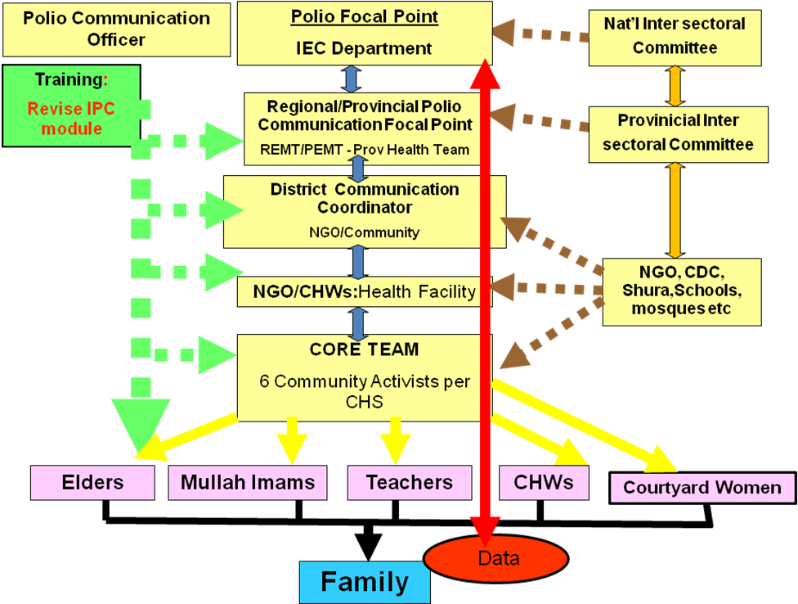

Monitoring Process
As the above figure shows increasing communication capacity at all levels will help in a number of ways by strengthening planning, training, implementation, analysis and monitoring. Once this capacity is in place further steps to improve all these areas will undoubtedly be suggested but the following small steps can be recommended to improve monitoring now:
- By next SIA: Ensure the consistent use of recently updated social mobilization campaign monitoring tools in all provinces.
- By next SIA: Ensure the regular collection and analysis of communication monitoring data for use in measuring impact and modifying activities (see figure 1).

Security
Tremendous efforts are being made at district level through innovations such as the Focused District Strategy (FDS) and access negotiators. There have been recent successes such as accessing 2 high risk districts not reachable for multiple rounds but active fighting in many areas means that clusters within districts remain totally inaccessible or so dangerous to work in that it is nearly impossible to verify quality and performance. While there is no simple way to address security problems, well planned communication can avoid making things worse and prepare the ground for improved access. The following recommendations are proposed:
- Immediately: Map and quantify inaccessible populations and areas at sub-district levels.
- Next SIA and ongoing: Intensify coordination between the Government of Afghanistan, ISAF, and other parties involved in the conflict to help support initiatives such as Days of Tranquility or more localized responses that will help improve access during SIAs. Campaign dates should be disseminated widely to all involved at all levels with several reminders prior to the campaign and feedback regarding any violation (fighting during campaign) should be reported for follow-up and action. Partners and donors should be actively involved in building support for such directives.
- Immediately: Assess and expand successful strategies such as access negotiators.
- By December 2007: Pilot the use of community monitoring to assess the quality of campaigns in hard to reach areas. This will require adequate training.
- Ongoing: In some cases the only way to gain access to a high risk area is to get permission from fighting factions including AGE’s. Where appropriate this strategy should be utilized.

Cross Border Issues and Mobile Populations
Strong efforts are being made to track and vaccinate mobile and border-crossing populations. There is a growing level of cooperation between Afghanistan and Pakistan and the synchronization of SIAs is a very positive development.
- By early 2008: Formalize cross border collaboration between the Afghanistan and Pakistan national PEI communication strategies including national maps of high risk border populations, social maps of key tribal, political or religious leaders and groups, advocacy plans for populations spanning borders and collaboration between both countries to focus on reaching these populations when they are most settled.
- Ongoing: Continue to hold regular meetings between provincial level teams and ensure they happen frequently with set agendas.
- Immediately: Improve communication, coordination, monitoring and supervision at the local level to ensure that decisions made at provincial or national levels are clearly communicated and understood by those implementing the programme at border posts.
- By November 2007: Improve coordination so that appropriate materials, messages and initiatives can be shared in border areas.
- By next SIA: Ensure the appropriate location, visibility and shelter for vaccination posts (especially permanent ones).

Follow-up to communication activities
The enhanced capacity for planning, monitoring, supervision and data collection/analysis outlined above will require ongoing follow-up and coordination within Afghanistan and on the TAG. This will require:
- By November 2007: Hold regular (every 2 months) national-level meetings attended by provincial communication focal points to review progress.
- By September 2007: Expand the mandate of the TAG to ensure it has the capacity to provide expert advice on communication by:
  - Including communication expertise on the TAG.
  - Ensuring the TAG receives regular updates from the national polio focal point regarding progress in the high risk provinces and on cross border activities.

Recommendation action plan
By October 2007: A time-bound action plan should be developed by the MoPH and partners to ensure implementation of these recommendations.

Schematic model to demonstrate the steps involved in evidence-based strategic approach to guiding PEI social mobilization and communication activities. Acronyms: PCA: post campaign assessment, DC – District Coordinator, CHW – Community Health Worker, CHS – Community Health Supervisor
A Knowledge, Attitude, Practice and Behaviour Change study has been planned for some time but needs to be accelerated.
The South East is included here because it borders with high risk areas in Pakistan has significant accessibility issues and should be considered as an area that may require expanded support for its polio programme. However, this should be considered as a possibility to plan for at this point and not for immediate implementation.
In the south and east a regional focal point will not be enough even with the support of the REMT. In these cases it will be necessary to include a provincial focal point in those provinces with significant areas of high risk or poor access to provide essential support.

